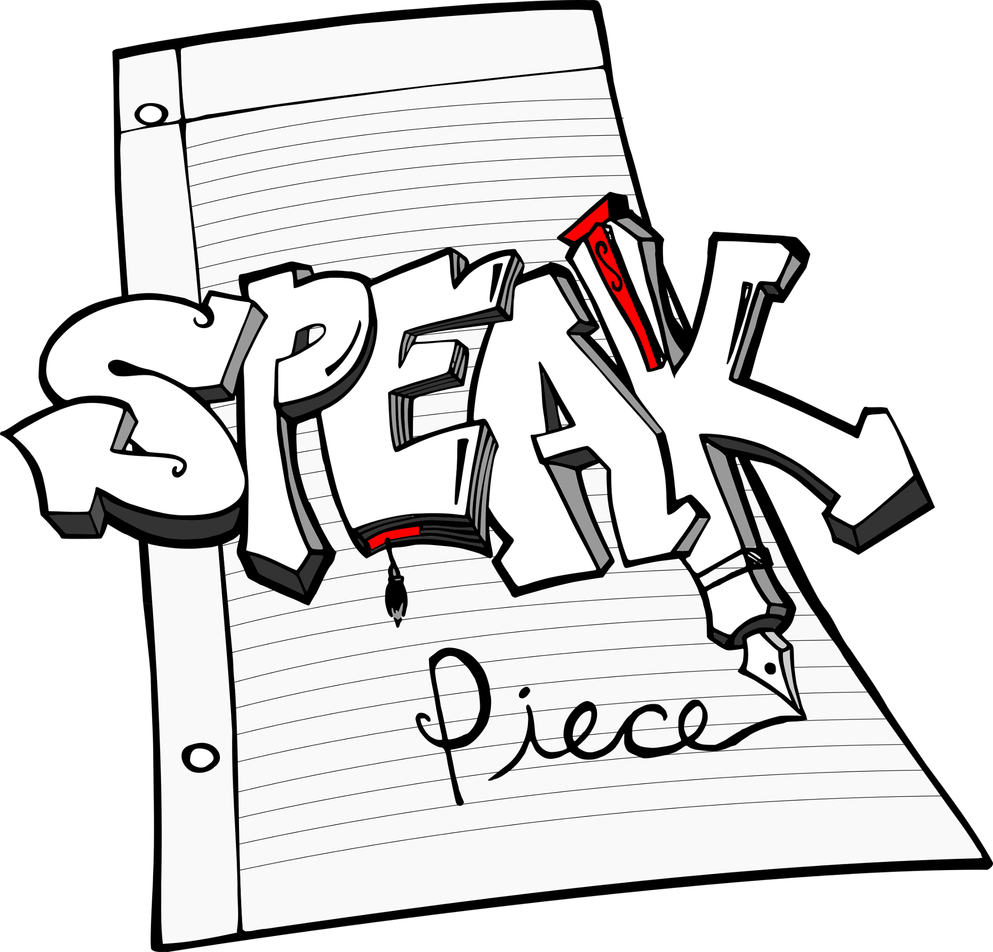

We are the Speak Piece Poetry Project, Austin’s youth spoken word & slam poetry organization.

Originally founded in 2003, Speak Piece (formerly known as the Texas Youth Word Collective/They Speak) has been a major part in the development and empowerment of Austin's youth. Now the Speak Piece Poetry Project is continuing that tradition on its own, empowering young voices through the craft of storytelling and spoken word.

The Austin spoken word community has produced scores of nationally recognized poets, coaches, and mentors. We are the organization that can best serve Austin's youth, with over ten years developing future readers, writers, and thinkers. Students who participate in the program will graduate to become critically thoughtful, socially active, and culturally-literate artists.

The “Speak Piece” youth poetry slam team is looking forward to its first year of competition. Our goal is to build a community of youth artists who are excited about not just self expression and determination, but also representing the City of Austin as a competitive unit. Students will be provided the opportunity to showcase their talent, while being introduced to like minded poets all over the region/country.

The “Poetry Project” sends our team of teaching artists to middle and high schools all over the Greater Austin area. In the first year of this program, we have reached over 400 students by offering presentations and workshops to schools who understand the need to develop the creativity, voices and confidence of their students. We also host free writing and performance workshops twice a month, to provide students with a safe space to create and explore.

Our feature event, the Austin youth slam team finals- Break the Mic, is on April 15th. If you feel that your son and daughter has what it takes to compete on a poetry slam team, we hope to see you on April 15th. Poets from all over the Austin area will competing for the four slots on the Speak Piece slam team. There will also be an open mic for poets who are not competing before the slam. Team members must be between 13 – 19 years old (cannot turn 20 before July 12, 2016).

We hope to see you there!

FAQ - BREAK THE MIC - APRIL 15TH

If you’ve never been to a poetry slam before, there are some frequently asked questions here that can help. You can also email us @ speakpiecepoetry@gmail.com.

Frequently Asked Questions

What is Break the Mic?
Break the Mic is the final poetry slam for the selection of the Speak Piece slam team, which takes place on April 15th, 2017, at the Dougherty Arts Center from 12pm-4pm.

The slam will be two rounds and poets should expect to at least perform their best two poems. The third poem will be used in the event of a tie. Once we crown our champion, the top 4 poets will be announced as the 2017 Speak Piece slam team!

Poems should be no longer than 3 minutes long. We like to recommend 2 minutes, 45 seconds (or 2:45) to give room for audience reaction. Poems don’t need to be memorized, but it’s always good to practice, practice, and practice some more before the slam.

This year, we expect to send a team of four youth poets, an adult coach, and two adult chaperones to the Speak Up, Speak Out youth slam in Bryan, Texas.

What is Speak Up, Speak Out?
The Mic Check Poetry Slam (Bryan,TX) hosts an annual youth poetry slam and workshop festival called Speak Up, Speak Out and we are planning to send a team to represent Austin. The Speak Piece Poetry Project will fundraise for and cover as much of the travel, lodging, registration, and meal costs as possible. Poets/parents may be asked to cover some costs associated with the trip.

The tournament dates/format have not been selected, but we will communicate with you directly, should your child/student be selected to participate on the team.

What is the Speak Piece slam team?
The Speak Piece slam team values performance, team work, and behavior and poets will be expected to sign a behavior/team rules agreement and medical waiver form. Parents/guardians will also be asked to sign.

The behavior/rules agreement will cover any additional questions or concerns you may have about team practices, featured guest appearances, and mentorship. Any other questions can be delivered to our staff via email @ speakpiecepoetry@gmail.com.

Frequently Asked Questions about slam poetry (from Poetry Slam, Inc.)

What is poetry slam?
Simply put, poetry slam is the competitive art of performance poetry. It puts a dual emphasis on writing and performance, encouraging poets to focus on what they’re saying and how they’re saying it. In competition, the poets are judged by members of the audience. Typically, the host or another organizer selects the judges, who are instructed to give numerical scores (on a zero to 10 or one to 10 scale) based on the poets’ content and performance.
What are the rules?
Though rules vary from slam to slam, the basic rules are:
- Each poem must be of the poet’s own construction;
- Each poet gets three minutes (plus a ten-second grace period) to read one poem. If the poet goes over time, points will be deducted from the total score.
- The poet may not use props, costumes or musical instruments;
- Of the scores the poet received from the five judges, the high and low scores are dropped and the middle three are added together, giving the poet a total score of 0-30.

How do I win a poetry slam?
Winning a poetry slam requires some measure of skill and a huge dose of luck. The judges’ tastes, the audience’s reactions, and the poets’ performances all shape a slam event, and what wins one week might not get a poet into the second round the next week. There’s no formula for winning a slam, although you become a better poet and performer the same way you get to Carnegie Hall – practice, practice, practice.

How did poetry slam start?
In 1984, construction worker and poet Marc Smith started a poetry reading at a Chicago jazz club, the Get Me High lounge, looking for a way to breathe life into the open mike format. The series, and its emphasis on performance, laid the groundwork for the brand of poetry that would eventually be exhibited in slam.
In 1986, Smith approached Dave Jemilo, the owner of the Green Mill (a Chicago jazz club and former haunt of Al Capone), with a plan to host a weekly poetry competition on Sunday nights. Jemilo welcomed him, and the Uptown Poetry Slam was born on July 25 of that year. Smith drew on baseball and bridge terminology for the name, and instituted the basic features of the competition, including judges chosen from the audience and cash prizes for the winner. The Green Mill evolved into a Mecca for performance poets, and the Uptown Poetry Slam continues to run every Sunday night.

Where to find slam poetry online

www.speakpiece.org

www.bravenewvoices.com

www.youtube.com/user/YOUTHSPEAKS

www.youtube.com/user/ButtonPoetry

www.youtube.com/user/WANpoetry

